Created on: 2/2/05
Topic: Early Models of the Universe and the Origins of Modern Astronomy

- Ancient astronomy (1000s of years ago)
  - People thought the Sun goes around the Earth and that the Earth was the center of the Universe
  - Aristarchus – Thought that the Earth was not the center of the Universe
    - Calculated the size of the Sun and the Moon
    - He figured out that the Sun is larger than the Earth, and the Moon is smaller than the Earth
    - People though he was wrong because they didn’t see the stars shifting (parallax) (they actually do shift, but VERY slowly)
    - The further away something is, the smaller the parallax
    - Parallax – The apparent motion of an object due to your own motion (i.e., looking at a forest while riding in a car and seeing trees in the foreground moving much faster than things in the background)
  - 7 exceptions:
    - Planets = Wanders (Day of the week named after the wanderer)
      - Sun (Sunday)
      - Moon (Monday)
      - Mercury (Wednesday)
      - Venus (Friday)
      - Mars (Tuesday)
      - Jupiter (Thursday)
      - Saturn (Saturday)
    - These planets experience retrograde: Mercury Venus Mars Jupiter and Saturn
    - Retrograde – The backwards/forwards motion of a planet as we see it from Earth
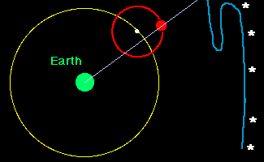
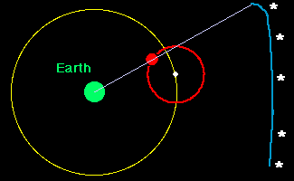

    - Epicycle – Blue path above (Mars’ path as we see it from Earth)

  - Ptolemy’s Model of the Universe
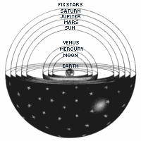

  - No one questioned his model for 1500 years
    - Because it worked well
    - Because it was part of the Catholic Church’s doctrine
  - The Arabs did a lot of research and made Arabic Numerals (0, 1, 2, 3, and so on)
- Modern astronomy
  - Nicholas Copernicus (500 years ago)
    - First to challenge Ptolemy’s model
    - He said the Sun was the center of the Universe
    - Copernicus’ explanation for retrograde: Earth is moving faster than the other planets
  - Tycho Brahe (400 years ago)
    - Believed the Earth was the center of the Universe and wanted to prove it
    - Spent 20 years gathering data
    - Hired Johannes Kepler to help him analyze the data
    - Brahe died and Kepler stole all of his data to try and prove the Sun was the center of the Universe

  - Kepler’s Laws of Planetary Motion:
    - 1. Law of Ellipses
      - Planets go around the Sun on an elliptical orbit

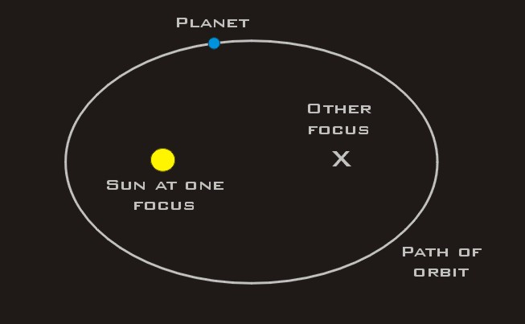
      - Perihelion – Planet is closest to the Sun
      - Aphelion – Planet is furthest from the sun
    - 2. Law of Equal Areas
      - Planets sweep out (travel) equal areas at equal times
      - A short fat area = a long skinny area
    - 3. Law of Periods
      - Orbital Period – amount of time it takes for a planet to go around the Sun
      - The orbital period squared is directly proportional to the semi major axis of its orbit cubed
      - Proportionality consistent is the same for all the planets
  - Galileo Galilee
    - Did not invent the telescope
    - He WAS the first person to point a telescope at the sky
    - Believed Sun was the center of the Universe
    - He saw:
      - Sunspots on the Sun
      - Mountains and craters on the Moon
      - Moons around Jupiter
      - Rings around Saturn
      - Phases of Venus
      - Billions of stars in the Milky Way band
    - Seeing the moons around Jupiter really convinced him that the Sun was the center of the Universe
    - Galileo had 4 moons named for him
    - Galileo discovered Newton’s first law before Newton
  - Newton (300 years ago)
    - Explained all of the above theories
    - Invented Calculus
    - Basically invented physics (3 laws of motion)
    - Newton’s Law of Universal Gravitation – Everything in the Universe attracts everything else in the Universe
    - Gravity is weak so we can’t feel the attraction towards other objects
    - Newton’s Gravitational Constant (Gravitational Constant of the Universe) –
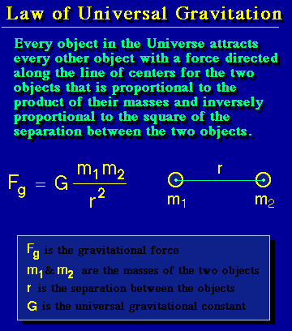

    - God-given constants
      - G = 6.67 * 10⁻¹¹ (small number, but not small if one of the ms is HUGE)
      - c = Speed of Light
      - h = Planck’s Constant
        - Energy of a photon = h * frequency
    - Commented that the way Kepler stated his laws where wrong so he corrected them
      - 1. Law of Ellipses
        - Trajectory must be a conic section
        - Conic Sections
          - Circle
          - Ellipse
          - Parabola
          - Hyperbola
      - 2. Law of Equal Areas
        - Anything orbiting anything else should sweep out equal areas in equal time
        - Angular momentum – Amount of rotation something has
        - Conservation (constant) of Angular momentum
        - Anything must orbit anything else with a conserved angular momentum
      - 3. Law of Periods
        - Can also be true for moons going around a planet
        - You can calculate the mass of something in space by finding the semi major axis of the orbit of an object that orbits the original object (i.e., to find the mass of the Earth, find the semi major axis of the orbit of the Moon)
    - Gravity = 9.8 meters/sec/sec downward
    - Everything falls towards anything else with the exact same acceleration if gravity is the only force acting on those objects
- Formula for acceleration due to gravity: g = G(M/r²)
    - Escape Velocity (Speed) Calculation
    - Explained the tides
      - Tidal Force – Difference in the gravitational force across an object
      - There are 2 high tides and 2 low tides everyday
      - The Sun and Moon are both responsible for the tides
      - New moon – Moon is between the Sun and the Earth
      - Full moon – Moon is behind the Earth and Sun
        - Spring tides – New/Full Moons cause these – severe high and low tides
        - Neap tides – Moon is 1st or 3rd quarter – modest high and low tides
      - Example:
        - Week 1 – New Moon – Spring tides
        - Week 2 – 1st quarter Moon – Neap tides
        - Week 3 – Full Moon – Spring tides
        - Week 4 – 3rd quarter Moon – Neap tides
    - Newton did all of this by the time he was in his 20s
    - Due to Newton there was a revolution in thinking in Europe
    - Newton is an important figure in world history
    - Newton claimed Leibniz stole his work when he actually didn’t

